The plan is to make a website with an online portal which can enable efficient charging of customers Solar batteries. Make it mobile responsive. (phase 2 might be to make an APP) APP not part of this request.

The intention is for the customer to make an account, to then make a connection to their Solar Inverter through an available API.

The customer will define some key elements under their account.

1. Customer data: Name, address, email, and then specify their Solar Inverter.

Here we anticipate the initial phase to include interfacing only “**one**” inverter type. Starting with say: Huawei Sun2000 inverters. They seemingly have an API.

The customer data will also include an option where the customer can provide access to <https://eloverblik.dk/welcome> this is an organization which has made an API allowing you to interface a request into their Database to gain insights on the customers historical energy usage. The system has a build in authentication method which the customer accepts. So it’s a matter of interfacing their system which then provides the login, and pulls the data required.

**Website Intelligent algorithm:**

Once the website interfaces the solar inverter and also interfaces the historical customer electricity data then we also need it to interface and gain daily electricity pricing once a day for 24 hours at a time. Such as from here: <https://www.nordpoolgroup.com/en/Market-data1/Dayahead/Area-Prices/DK/Hourly/?view=table>

Additionally then it should look at the weather for the day ahead and take in some daily measurements based on the customers address. <https://www.dmi.dk/lokation/show/DK/2624652/Aarhus/>

How many hours of “sun light” in the day, how much expected sun etc.

The ultimate plan here is for the algorithm to take:

Sun hours + Electricity Pricing + Historical Electricity usage into account and then decide when the best time is to charge up and discharge the solar battery.

If it’s August and full sun and the historical electricity usage is low for August then the system will likely ensure the battery is charged up by the sun during the day time and then used at night time.

If it’s wintertime, cloudy, then the system will know that it makes sense to charge the battery at nighttime where the electricity price potentially low to then discharge in the morning and then charge up again later in the day to then discharge during the peak expensive electricity times from say 17:00 – 21:00

As an example.

Below is an image where the green shows charging on cheap electricity and then red colour using the battery, then charging again partly on the sun then discharging again.

The aim is for the system to know what is “cheapest” and then send a daily plan to the inverter. So each day the system looks at what is best and then sends instructions through the API to the Inverter so it’s knows what to do.

The focus is review what is the cheapest plan based on the known input variables. This prevents a customer from having to manually set these settings every single day if they are to gain the maximum amount.

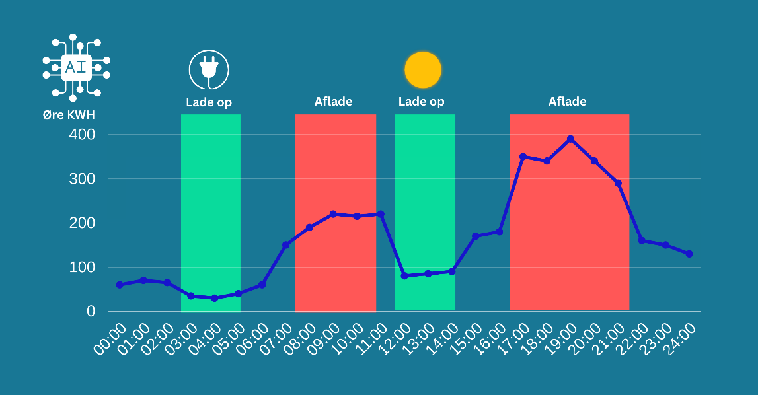

Here is an example of the quality of website portal. (high level suggestive only)

The customer should be able to make some preferences like a sliding scale on preference for Solar charging v charging from Electricity when pricing is cheap and then to also have an option of just letting the “AI” or algorithm handle it automatically – so AUTO.

Graph should give a readout of the solar production for the day. API should provide that.

Graph should show the savings made by the system v not having a battery.

This is basically the historical days KWH used for the house at the variable electricity price known. V the price that is then paid by charging and discharging the battery and thus saving.

So say the household X uses 40 KWH in a 24 hours period. With no battery the cost would be 40 * the Electricy price for each hour as per: <https://www.nordpoolgroup.com/en/Market-data1/Dayahead/Area-Prices/DK/Hourly/?view=table>

The saving would be battery capacity (say 10 KW) * the cheaper charged price minus the cost during that period. Etc.. Finer details can be made later on this point.